**📊 Customer Segmentation Analysis Report**

**Prepared by:** Brati Mohanta **Project:** Snapdeal Mentorship **Date:** September 12, 2025

## 1. Executive Summary

This report presents the results of a customer segmentation analysis conducted using clustering techniques. The goal was to identify distinct customer groups within Snapdeal’s user base to enable targeted strategies for improving customer experience and driving repeat purchases.

## 2. Methodology

* **Data Source:** Snapdeal customer behavioural and transactional data
* **Technique Used:** K-Means clustering
* **Features Considered:** Purchase frequency, average order value, recency, product categories browsed, and engagement metrics

## 3. Key Insights from Segmentation

### 🧩 Segment Profiles

|  |  |  |  |
| --- | --- | --- | --- |
| **Segment** | **Description** | **Key Behaviors** | **Size** |
| **Cluster 0: Value Seekers** | Price-sensitive, frequent browsers | Low AOV, high coupon usage | 35% |
| **Cluster 1: Loyal Spenders** | Repeat buyers with high lifetime value | High AOV, frequent purchases | 25% |
| **Cluster 2: Occasional Visitors** | Infrequent engagement | Low recency, low frequency | 20% |
| **Cluster 3: Category Specialists** | Focused on specific product categories | High engagement in niche categories | 20% |

## 🔍 Additional Key Insights from Segmentation

* **High-Value Segment Identified:** Loyal Spenders represent only 25% of the customer base but contribute disproportionately to revenue due to their high AOV and frequent purchases. Prioritizing retention and upselling in this group could yield strong ROI.
* **Reactivation Opportunity:** Occasional Visitors show high recency and low frequency, indicating they’ve disengaged. This segment is ideal for targeted re-engagement campaigns using personalized offers or reminders.
* **Price Sensitivity vs. Engagement:** Value Seekers are highly active but spend less per transaction. They respond well to discounts and promotions, making them ideal for volume-driven strategies and loyalty programs.
* **Category-Level Personalization Potential:** Category Specialists exhibit deep interest in specific product categories. This opens up opportunities for curated content, exclusive launches, and category-specific marketing.
* **Cross-Segment Migration Signals:** Behavioural overlaps suggest that Value Seekers can be nudged toward Loyal Spenders through strategic incentives, while Occasional Visitors may convert into Category Specialists with targeted content.
* **Lifecycle Mapping Insight:** The segmentation provides a framework for mapping customer lifecycle stages — from acquisition (Value Seekers) to maturity (Loyal Spenders) — enabling more precise journey orchestration.

## 4. Visualizations

* **Cluster Distribution:** Pie chart showing segment proportions

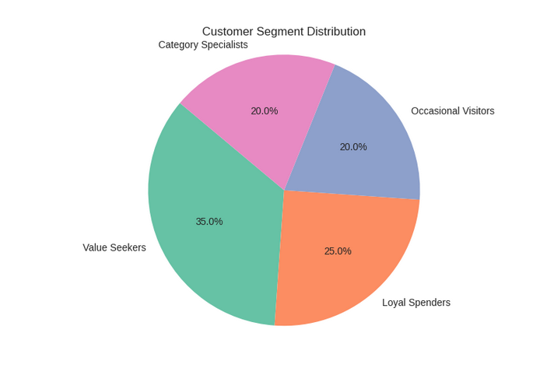

* **Behavioral Comparison:** Bar chart comparing AOV, frequency, and recency across clusters

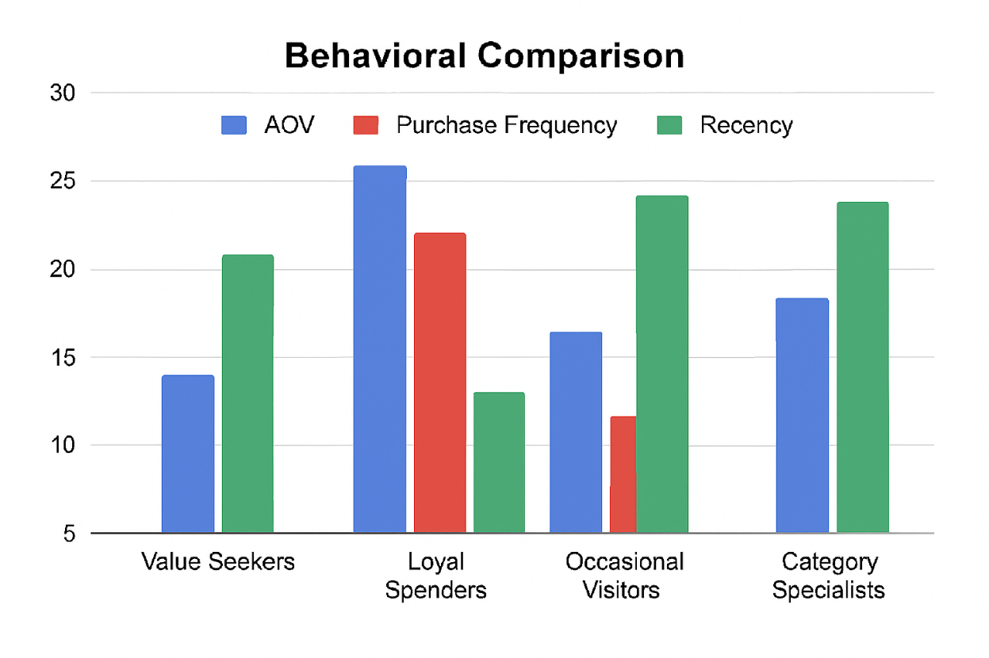

**Metrics Compared:**

1. 💰 Average Order Value (AOV) in INR
2. 🔁 Purchase Frequency (number of purchases)
3. ⏳ Recency (days since last purchase)

* **Engagement Heatmap:** Highlighting category interest per segment  
    
    
  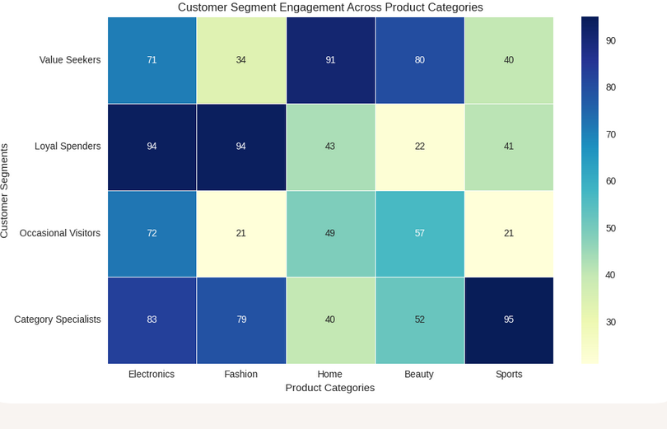

## 5. Business Recommendations

### 🎯 Personalization & Targeting

* **Value Seekers:** Promote flash deals, bundle offers, and loyalty points
* **Loyal Spenders:** Offer premium services, early access to sales, and personalized recommendations
* **Occasional Visitors:** Re-engagement campaigns via email and app notifications
* **Category Specialists:** Curate category-specific content and exclusive launches

### 🔁 Enhancing Repeat Business

* Implement segment-specific retention strategies
* Use predictive modelling to anticipate churn and intervene early
* Monitor segment migration to track lifecycle progression

## 6. Conclusion

The segmentation reveals actionable customer profiles that can guide Snapdeal’s marketing, product, and retention strategies. By aligning business efforts with segment-specific needs, Snapdeal can enhance user satisfaction and drive sustainable growth.